# VISVESVARAYA TECHNOLOGICAL UNIVERSITY

## BELAGAVI – 590018, Karnataka INTERNSHIP REPORT

#### ON

“Automated Parking System using ML”

***Submitted in partial fulfilment for the award of degree(21****)***

## BACHELOR OF ENGINEERING IN

## ELECTRONICS & COMMUNICATION

***Submitted by:***

**Name: Shakthi B S**

**USN: 4AI20EC082**



Conducted at

**COMPSOFT TECHNOLOGIES**



**ADICHUNCHANAGIRI INSTITUTE OF TECHNOLOGY**

**Department of Electronics & Communication**

**Accredited by NAAC, New Delhi**

**ADICHUNCHANAGIRI INSTITUTE OF TECHNOLOGY**

**Department of Electronics & Communication**

**Accredited by NAAC, New Delhi**



**CERTIFICATE**

This is to certify that the Internship titled **“Automated Parking System using ML”** carried out by **Mr. SHAKTHI B S,** a bonafide student of Adichunchanagiri Institute of Technology, in partial fulfillment for the award of **Bachelor of Engineering**, in **ELECTRONICS & COMMUNICATION** under Visvesvaraya Technological University, Belagavi, during the year 2023-2024. It is certified that all corrections/suggestions indicated have been incorporated in the report.

The project report has been approved as it satisfies the academic requirements in respect of Internship prescribed for the course Internship / Professional Practice (4AI20EC082)

#### Signature of Guide Signature of HOD Signature of Principal

**External Viva:**

Name of the Examiner Signature with Date

1)

2)

# D E C L A R A T I O N

I, **Mr. SHAKTHI B S**, final year student of ELECTRONICS & COMMUNICATION, Adichunchanagiri Institute Of Technology- 577 102, declare that the Internship has been successfully completed, in **COMPSOFT TECHNOLOGIES**. This report is submitted in partial fulfillment of the requirements for award of Bachelor Degree in ELECTRONICS & COMMUNICATION, during the academic year 2023-2024.

Date : 2/12/2023

Place: Chikkamagaluru :

USN : 4AI20EC082

NAME : SHAKTHI B S

**OFFER LETTER**

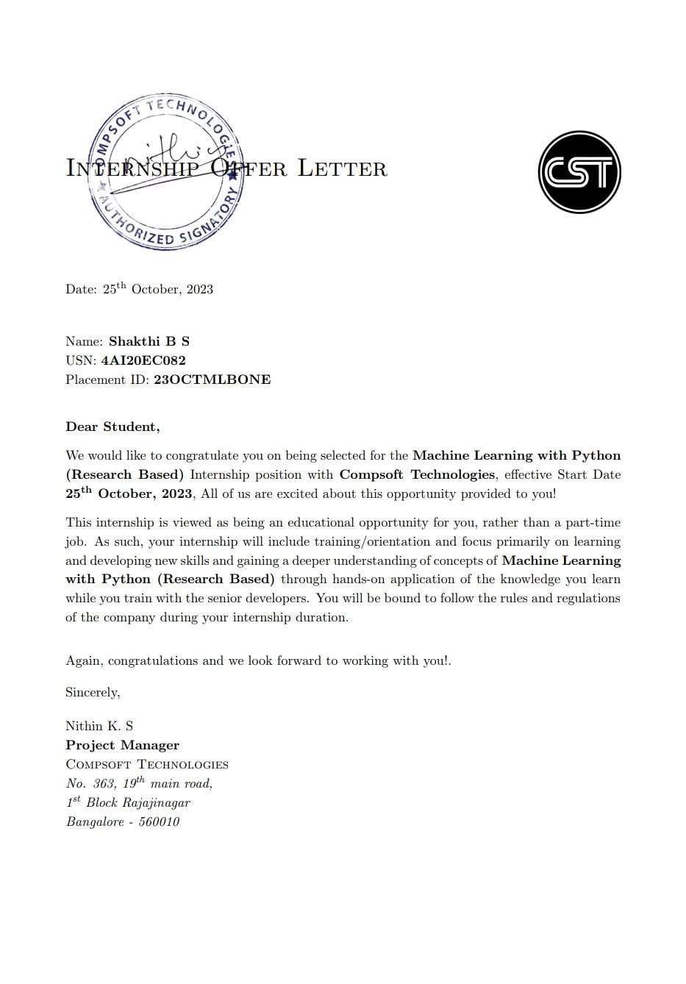

# A C K N O W L E D G E M E N T

This Internship is a result of accumulated guidance, direction and support of several important persons. We take this opportunity to express our gratitude to all who have helped us to complete the Internship.

We express our sincere thanks to our Principal, for providing us adequate facilities to undertake this Internship.

We would like to thank our Head of Dept – ELECTRONICS & COMMUNICATION , for providing us an opportunity to carry out Internship and for his valuable guidance and support.

We would like to thank our Lab assistant Software Services for guiding us during the period of internship.

We express our deep and profound gratitude to our Guide, for her keen interest and encouragement at every step in completing the Internship.

We would like to thank all the faculty members of our department for the support extended during the course of Internship.

We would like to thank the non-teaching members of our dept, forhelping us during the Internship.

Last but not the least, we would like to thank our parents and friends without whose constant help, the completion of Internship would have not been possible.

**NAME: SHAKTHI B S**

**USN: 4AI20EC082**

# ABSTRACT

Automated Parking System (APS) using Machine Learning (ML) could highlight the system's integration of advanced ML algorithms to optimize parking space utilization, enhance vehicle navigation, and streamline the parking process. It may emphasize the system's ability to adapt to real-time conditions, improving efficiency and reducing congestion. Additionally, the abstract might touch upon the positive environmental impact through reduced fuel consumption and emissions, showcasing the potential for ML-driven APS to revolutionize urban parking management.

The Automated Parking System is a modern approach to resolve the parking issues in our country. This application will help all the users to find the perfect parking spot in shopping complexes or a public parking system. It has an additional feature of securing the vehicle using Face Recognition. This research designs an intelligent parking system including service application layer, perception layer, data analysis layer, and management layer. The network system adopts opm15 system, and the parking space recognition adopts improved convolution neural networks (CNNs) algorithm and image recognition technology. Firstly, the parking space is occupied and located, and the shortest path (Dynamic Programming, DP) is selected. In order to describe the path algorithm, the parking system model is established. Aiming at the problems of DP low power and adjacent path interference in the path detection system, a method of combining interference elimination technology with enhanced detector technology is proposed to effectively eliminate the interference path signal and improve the performance of the intelligent parking system. In order to verify whether the CNNs system designed in this study has advantages, the simulation experiments of CNNs, ZigBee, and manual parking are carried out. The results show that the parking system designed in this study can control the parking error, has smaller parking error than ZigBee, and has more than 25.64% less parking time than ZigBee, and more than 34.83% less time than manual parking. In terms of parking energy consumption, when there are less free parking spaces, CNNs have lower energy consumption.

# Table of Contents

|  |  |  |
| --- | --- | --- |
| **Sl no** | **Description** | **Page no** |
| 1 | Company Profile | 8-9 |
| 2 | About the Company | 10-13 |
| [3](https://1.bp.blogspot.com/-dODuK8N5h1Q/Wlnyb3V9HFI/AAAAAAAACL4/WxQtCJ1pM5wccDABg4wIrTBUB0vlikXQQCLcBGAs/s1600/poly1.jpg) | Introduction | 14-15 |
| [4](https://1.bp.blogspot.com/-dODuK8N5h1Q/Wlnyb3V9HFI/AAAAAAAACL4/WxQtCJ1pM5wccDABg4wIrTBUB0vlikXQQCLcBGAs/s1600/poly1.jpg) | System Analysis | 16-20 |
| [5](https://1.bp.blogspot.com/-dODuK8N5h1Q/Wlnyb3V9HFI/AAAAAAAACL4/WxQtCJ1pM5wccDABg4wIrTBUB0vlikXQQCLcBGAs/s1600/poly1.jpg) | Requirement Analysis | 21-24 |
| 6 | Design [Analysis](https://4.bp.blogspot.com/-IOOxgPaXMVc/Wlj3LWvcnjI/AAAAAAAACKE/UeTFYvAxDmUDel5UBjdifeWaApB3-dXVgCLcBGAs/s1600/img1.jpg) | 25-27 |
| 7 | [Implementation](https://4.bp.blogspot.com/-IOOxgPaXMVc/Wlj3LWvcnjI/AAAAAAAACKE/UeTFYvAxDmUDel5UBjdifeWaApB3-dXVgCLcBGAs/s1600/img1.jpg) | 28-29 |
| 8 | Snapshots | 30-32 |
| 9 | Conclusion | 33-34 |
| 10 | References | 35-36 |

[**CHAPTER**](https://1.bp.blogspot.com/-dODuK8N5h1Q/Wlnyb3V9HFI/AAAAAAAACL4/WxQtCJ1pM5wccDABg4wIrTBUB0vlikXQQCLcBGAs/s1600/poly1.jpg) **1** **COMPANY PROFILE**

# COMPANY PROFILE

## A Brief History of Compsoft Technologies

Compsoft Technologies, was incorporated with a goal ”To provide high quality and optimal Technological Solutions to business requirements of our clients”. Every business is a different and has a unique business model and so are the technological requirements. They understand this and hence the solutions provided to these requirements are different as well. They focus on clients requirements and provide them with tailor made technological solutions. They also understand that Reach of their Product to its targeted market or the automation of the existing process into e-client and simple process are the key features that our clients desire from Technological Solution they are looking for and these are the features that we focus on while designing the solutions for their clients.

Sarvamoola Software Services. is a Technology Organization providing solutions for all web design and development, MYSQL, PYTHON Programming, HTML, CSS, ASP.NET and LINQ. Meeting the ever increasing automation requirements, Sarvamoola Software Services. specialize in ERP, Connectivity, SEO Services, Conference Management, effective web promotion and tailor-made software products, designing solutions best suiting clients requirements.

Compsoft Technologies, strive to be the front runner in creativity and innovation in software development through their well-researched expertise and establish it as an out of the box software development company in Bangalore, India. As a software development company, they translate this software development expertise into value for their customers through their professional solutions.

They understand that the best desired output can be achieved only by understanding the clients demand better. Compsoft Technologies work with their clients and help them to defiine their exact solution requirement. Sometimes even they wonder that they have completely redefined their solution or new application requirement during the brainstorming session, and here they position themselves as an IT solutions consulting group comprising of high caliber consultants.

They believe that Technology when used properly can help any business to scale and achieve new heights of success. It helps Improve its efficiency, profitability, reliability; to put it in one sentence ” Technology helps you to Delight your Customers” and that is what we want to achieve.

# [CHAPTER](https://1.bp.blogspot.com/-dODuK8N5h1Q/Wlnyb3V9HFI/AAAAAAAACL4/WxQtCJ1pM5wccDABg4wIrTBUB0vlikXQQCLcBGAs/s1600/poly1.jpg) 2 ABOUT THE COMPANY

1. **ABOUT THE COMPANY**



Compsoft Technologies is a Technology Organization providing solutions for all web design and development, MYSQL, PYTHON Programming, HTML, CSS, ASP.NET and LINQ. Meeting the ever increasing automation requirements, Compsoft Technologies specialize in ERP, Connectivity, SEO Services, Conference Management, effective web promotion and tailor-made software products, designing solutions best suiting clients requirements. The organization where they have a right mix of professionals as a stakeholders to help us serve our clients with best of our capability and with at par industry standards. They have young, enthusiastic, passionate and creative Professionals to develop technological innovations in the field of Mobile technologies, Web applications as well as Business and Enterprise solution. Motto of our organization is to “Collaborate with our clients to provide them with best Technological solution hence creating Good Present and Better Future for our client which will bring a cascading a positive effect in their business shape as well”. Providing a Complete suite of technical solutions is not just our tag line, it is Our Vision for Our Clients and for Us, We strive hard to achieve it.

## Products of Compsoft Technologies.

**Android Apps**

It is the process by which new applications are created for devices running the Android operating system. Applications are usually developed in Java (and/or Kotlin; or other such option) programming language using the Android software development kit (SDK), but other development environments are also available, some such as Kotlin support the exact same Android APIs (and bytecode), while others such as Go have restricted API access.

The Android software development kit includes a comprehensive set of development tools. These include a debugger, libraries, a handset emulator based on QEMU, documentation, sample code, and zutorials. Currently supported development platforms include computers running Linux (any modern desktop Linux distribution), Mac OS X 10.5.8 or later, and Windows 7 or later. As of March 2015, the SDK is not available on Android itself, but softwaredevelopment is possible by using specialized Android applications.

**Web Application**

It is a client–server computer program in which the client (including the user interface and client- side logic) runs in a web browser. Common web applications include web mail, online

retail sales, online auctions, wikis, instant messaging services and many other functions. web applications use web documents written in a standard format such as HTML and JavaScript,which are supported by a variety of web browsers. Web applications can be considered as a specifific variant of client–server software where the client software is downloaded to the client machine when visiting the relevant web page, using standard procedures such as HTTP. The Client web software updates may happen each time the web page is visited. During the session, the web browser interprets and displays the pages, and acts as the universal client for any web application. The use of web application frameworks can often reduce the number of errors in a program, both by making the code simpler, and by allowing one team to concentrate on the framework while another focuses on a specifified use case. In applications which are exposed to constant hacking attempts on the Internet, security- related problems can be caused by errors in the program.

Frameworks can also promote the use of best practices such as GET after POST. There are some who view a web application as a two-tier architecture. This can be a “smart” client that performs all the work and queries a “dumb” server, or a “dumb” client that relies on a “smart” server. The client would handle the presentation tier, the server would have the database (storage tier), and the business logic (application tier) would be on one of them or on both. While this increases the scalability of the applications and separates the display and the database, it still doesn‟t allow for true specialization of layers, so most applications will outgrow this model. An emerging strategy for application software companies is to provide web access to software previously distributed as local applications. Depending on the type of application, it may require the development of an entirely different browser-based interface, or merely adapting an existing application to use different presentation technology. These programs allow the user to pay a monthly or yearly fee for use of a software application without having to install it on a local hard drive. A company which follows this strategy is known as an application service provider (ASP), and ASPs are currently receiving much attention in the software industry.

Security breaches on these kinds of applications are a major concern because it can involve both enterprise information and private customer data. Protecting these assets is an important part of any web application and there are some key operational areas that must be included in the development process. This includes processes for authentication, authorization, asset handling, input, and logging and auditing. Building security into the applications from the beginning can be more effective and less disruptive in the long run.

**Web design**

It is encompasses many different skills and disciplines in the production and maintenance of websites. The different areas of web design include web graphic design; interface design; authoring, including standardized code and proprietary software; user experience design; and

search engine optimization. The term web design is normally used to describe the design process relating to the front-end (client side) design of a website including writing mark up. Web design partially overlaps web engineering in the broader scope of web development. Web designers are expected to have an awareness of usability and if their role involves creating mark up then they are also expected to be up to date with web accessibility guidelines. Web design partially overlaps web engineering in the broader scope of web development.

## Departments and services offered

Compsoft Technologies plays an essential role as an institute, the level of education, development of student’s skills are based on their trainers. If you do not have a good mentor then you may lag in many things from others and that is why we at Compsoft Technologies gives you the facility of skilled employees so that you do not feel unsecured about the academics. Personality development and academic status are some of those things which lie on mentor’s hands. If you are trained well then you can do well in your future and knowing its importance of Compsoft Technologies always tries to give you the best.

They have a great team of skilled mentors who are always ready to direct their trainees in the best possible way they can and to ensure the skills of mentors we held many skill development programs as well so that each and every mentor can develop their own skills with the demands of the companies so that they can prepare a complete packaged trainee.

## Services provided by Compsoft Technologies.

* Core Java and Advanced Java
* Web services and development
* Dot Net Framework
* Python
* Selenium Testing
* Conference / Event Management Service
* Academic Project Guidance
* On The Job Training
* Software Training

# [CHAPTER](https://1.bp.blogspot.com/-dODuK8N5h1Q/Wlnyb3V9HFI/AAAAAAAACL4/WxQtCJ1pM5wccDABg4wIrTBUB0vlikXQQCLcBGAs/s1600/poly1.jpg) 3 INTRODUCTION

1. **INTRODUCTION**

## Introduction to ML

Machine Learning (ML) is a subset of artificial intelligence that focuses on developing algorithms and models that enable computers to learn from data and make predictions or decisions without explicit programming. By leveraging statistical techniques, ML algorithms analyze patterns in data, allowing systems to improve their performance over time. ML is widely applied in various domains, from image recognition and natural language processing to recommendation systems and autonomous vehicles. The ability to adapt and learn from new information makes ML a powerful tool for solving complex problems and enhancing decision-making processes in diverse fields.

Machine Learning is a branch of the broader field of artificial intelligence that makes use of statistical models to develop predictions. It is often described as a form of predictive modelling or predictive analytics and traditionally, has been defined as the ability of a computer to learn without explicitly being programmed to do so.

In basic technical terms, machine learning uses algorithms that take empirical or historical data in, analyze it, and generate outputs based on that analysis. In some approaches, the algorithms work with so-called “training data” first and then they learn, predict, and find ways to improve their performance over time. Machine learning is programming computers to optimize a performance criterion using example data or past experience. We have a model defined up to some parameters, and learning is the execution of a computer program to optimize the parameters of the model using the training data or past experience.

## Problem Statement

## The problem statement for an Automated Parking System (APS) using Machine Learning (ML) could address the challenges associated with traditional parking management, such as inefficient space utilization, increased congestion, and time-consuming navigation for drivers. It may highlight the need for a smart and adaptive solution that leverages ML to optimize parking space allocation, enhance real-time decision-making for parking assignments, and minimize the environmental impact of circling vehicles. The statement should emphasize the goal of developing an intelligent APS that not only streamlines the parking process but also contributes to overall urban mobility and sustainability.

The problem at hand involves the inefficiencies and challenges in conventional parking systems, including suboptimal space utilization, prolonged search times for available parking spots, and increased traffic congestion. The aim is to address these issues by implementing an Automated Parking System (APS) empowered by Machine Learning (ML). The goal is to develop a solution that uses ML algorithms to intelligently manage parking spaces, optimize navigation for drivers, and contribute to a more streamlined and sustainable urban parking experience.

# [CHAPTER](https://1.bp.blogspot.com/-dODuK8N5h1Q/Wlnyb3V9HFI/AAAAAAAACL4/WxQtCJ1pM5wccDABg4wIrTBUB0vlikXQQCLcBGAs/s1600/poly1.jpg) 4 SYSTEM ANALYSIS

**4. SYSTEM ANALYSIS**

## Existing System

## The very first step in a parking space detection system is to identify the parking spots. There are a few techniques to do this. For example, identifying the parking spots by locating the parking lines in a spot. This can be done using the edge detectors that OpenCV provides. But the problem here is that all parking locations don’t have these pre-defined boundaries. Another approach we can use is to assume that the cars that don’t move for a long time are in parking spaces. In other words, valid parking spaces are just places containing non-moving cars. But, this also doesn’t seem to be reliable. may lead to false positives and true negatives which is not acceptable in case of parking system. The Parking Guidance and Information System (PGIS) is a system which provides information about the nearest car park and the number of vacancies available to drivers. This system can be commonly located in big urban cities. The Variable Message Display (VMS) and other methods such as radios and phones are used to provide information regarding parking spaces availability to the patrons. The information provides the occupancy status of car parks or selected car park around the city with a range of capability of displaying Full/Available at the entrance (o guide the user to the respective vacant area. In order to detect the space usage in the car park, vehicle detectors are installed at the entrance, exits and/or at individual parking space. Common choices of detector used include loop detectors, machine vision, ultrasonic, infrared, microwave and lasers. An example of PGIS has been illustrated by Seong et al. (2008) in their paper which consists of a Wireless Sensor Network (WSN) based VDS (vehicle detection sub-system) and a management subsystem.

## Proposed System

The proposed system is divided into four modules; 1. Insertion of union 2. Initialization of boundaries 3. Allocation of boundaries to the system 4. Tracking the vehicle using video surveillance This project, vehicle parking management system using vedio processing aims to create a better environment for a vision based vacancy parking area detection; providing a modern and innovative solution for temporary parking places. For example, dust ground, cemented flooring where no specific parking systems are used. The prime objective is to have maximum number of cars which can be parked in an organized manner into the temporary lot. This project’s aim is to detect and recognize the real time vacant parking space. . It comprises of a camera mounted on roof top of any nearby building or some supporting pole at certain angle where it covers the maximum area of parking lot which is being used for taking the input. The images obtained from the live stream are then fed to the processing module, which detects the region of interest (ROI) consisting of the area to be covered for parking spaces. To detect cars in a video.

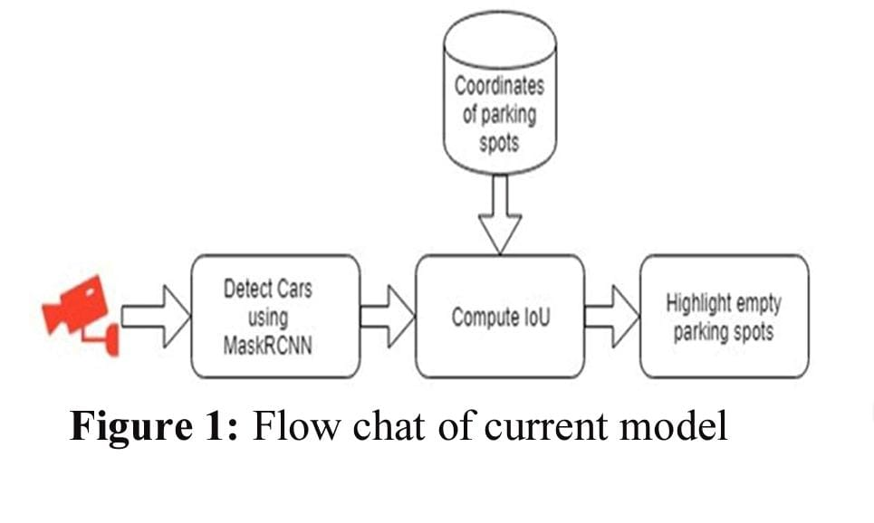

Intersection Over Union

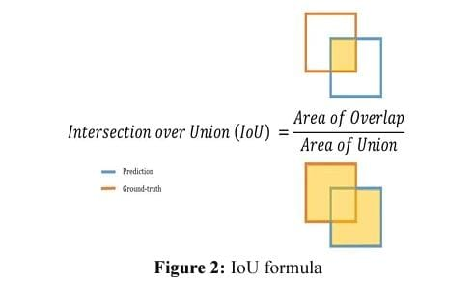

We will compute the IoU for every pair of parking spot coordinates and bounding box of cars. If the IoU for a pair is higher than a certain threshold, we will consider that parking spot as occupied.

Initializing Boundaries

The imaginary parking lines are made to achieve maximum parking, since the cars are not parked in correct way, car area needs to be calculated which resides inside a proper parking slot. Since in the image the unit of distance measurement is a pixel whereas actual distances are in the unit of feet, an equation is used as the conversion formula to find the number of pixels per metric. We will first use the Mask-RCNN object detection model to detect the cars and their bounding boxes. After getting the bounding boxes from the Mask-RCNN, we will compute the Intersection over Union (IoU) on each pair of the bounding boxes and parking spot coordinates. If the IoU value for any parking spot is greater than a certain threshold, we will consider that parking spot as occupied.

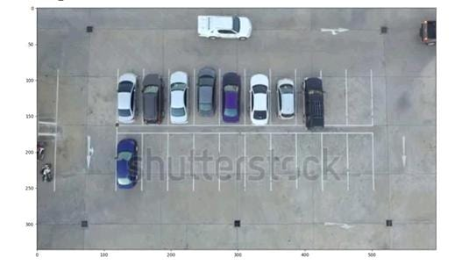

Fig: Before Making the Boundaries

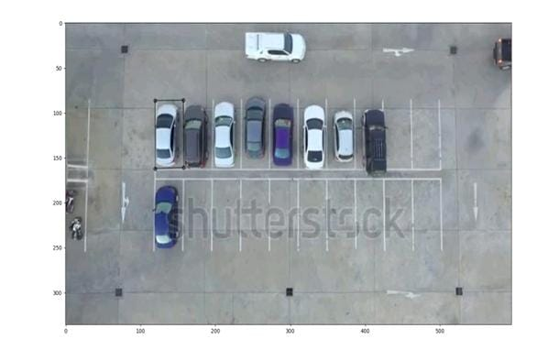

Fig: After Making the Boundaries

Allocation of Boundaries to the System

The boundaries of the parking slot is allocated to the system using the following Library

TensorFlow

TensorFlow is an end-to-end open source platform for machine learning. It has a comprehensive, flexible ecosystem of tools, libraries and community resources that lets researchers push the state-of-the-art in ML and developers easily build and deploy ML powered applications. TensorFlow provides a collection of workflows with intuitive, high-level APIs for both beginners and experts to create machine learning models in numerous languages. Developers have the option to deploy models on a number of platforms such as on servers, in the cloud, on mobile and edge devices, in browsers, and on many other JavaScript platforms. This enables developers to go from model building and training to deployment much more easily.

OpenCV

OpenCV is a library of programming functions mainly aimed at real-time computer vision. Originally developed by Intel, it was later supported by Willow Garage then Itseez. The library is cross-platform and free for use under the open-source Apache 2 License. OpenCV is a library of programming functions mainly aimed at real-time computer vision. Originally developed by Intel, it was later supported by Willow Garage then Itseez. The library is cross-platform and free for use under the open-source Apache 2 License.

Tracking of vehicle using video Surveillance

The imaginary parking lines are made to achieve maximum parking, since the cars are not parked in correct way, car area needs to be calculated which resides inside a proper parking slot. To handle with this, three classes have been defined, namely, the car class, the parking class and the intersect class. The car class contain the coordinate of car, the boolean either car is corrected parked or not and all value of all slot that car had occupied.

## Objective of the System

Automated parking system using machine learning is to enhance efficiency, reduce human intervention, and optimize parking space utilization. ML algorithms can analyze real-time data from cameras, sensors, and other sources to automate parking processes such as vehicle detection, navigation, and allocation of parking spaces. This improves overall system responsiveness, minimizes congestion, and provides a more convenient and streamlined parking experience for users. Camera images of the parking area are subjected to image processing algorithm which marks virtual slots in the area and extracts occupancy information to guide the incoming drivers about availability and position of vacant spaces.

At the entry and exit gates, parking tickets can be easily verified against the vehicle captured with the help of ANPR feature.

The Integrated Parking System is quite helpful in detecting lost/stolen vehicle.

Helps in identifying whether the vehicle entering in the parking area is paid or unpaid.

Tracks entry of undesired vehicles in protected parking zones such as hospitals or government premises.

The basic objective of a Automated parking solution is to identify a vehicle’s presence or absence in a particular parking space with a high degree of accuracy, and to pass on this data into a system for visualization and analysis – to be available for parking asset managers and/or enforcement officers.

Keeping in mind the objectives mentioned above, the next step is to take into consideration following important features:

Accuracy of detecting a vehicle presence/absence

Total cost of solution

Privacy concerns

The laser scanner sensors are well known for their accuracy of detecting a vehicle presence – therefore the sensor located at the entrance and exit of a parking area will count with high accuracy the entrance and exit of the vehicles, taking into consideration even two cars stopping very close to each other.

The total cost of solution considering the initial purchasing and installation cost, you will have low maintenance cost and no need of replacing batteries.

The sensors will just count the vehicles without recording any data. The system is not based on cameras, but again on sensors and eventually a display for counting the cars. Therefore, the privacy is totally granted.

Sensor solution is a reliable, and cost-effective modern Automated parking solution.

# [CHAPTER](https://1.bp.blogspot.com/-dODuK8N5h1Q/Wlnyb3V9HFI/AAAAAAAACL4/WxQtCJ1pM5wccDABg4wIrTBUB0vlikXQQCLcBGAs/s1600/poly1.jpg) 5 REQUIREMENT ANALYSIS

**5. REQUIREMENT ANALYSIS**

## Hardware Requirement Specification

The hardware specifications for an automated car parking system using machine learning can vary based on the specific requirements and complexity of the system. However, here are some essential components:

1. *Cameras and Sensors:*

- High-resolution cameras for capturing images and video data.

- Proximity sensors, ultrasonic sensors, or LiDAR for detecting vehicles and obstacles.

- Infrared sensors for night vision.

2. *Processing Unit:*

- Powerful processors (e.g., multi-core CPUs or GPUs) to handle real-time data processing and machine learning computations.

- Dedicated hardware for accelerated ML tasks, such as TPUs (Tensor Processing Units) or GPUs.

3. *Memory:*

- Sufficient RAM for storing and processing large datasets.

4. *Storage:*

- SSDs or HDDs for storing historical data, model parameters, and software.

5. *Communication Modules:*

- High-speed network interfaces for seamless communication between components.

- Connectivity options like Wi-Fi, Bluetooth, or cellular for remote monitoring and control.

6. *Control Unit:*

- Microcontrollers or embedded systems for managing actuators, motors, and other mechanical components.

7. *Power Supply:*

- Reliable power source with backup systems to ensure continuous operation.

8. *Display and User Interface:*

- Touchscreen displays or LED panels for user interaction and system feedback.

9. *Enclosures and Mounting:*

- Weather-resistant and durable enclosures to protect hardware components.

- Mounting brackets for cameras and sensors.

10. *Cooling Systems:*

- Fans or other cooling mechanisms to prevent overheating, especially for high-performance processors.

11. *Security Features:*

- Encryption and secure authentication protocols to protect data and system integrity.

12. *Remote Monitoring and Maintenance:*

- Remote access capabilities for monitoring system performance and conducting maintenance.

Ensure that the selected hardware meets the scalability and reliability requirements of the automated parking system. Additionally, consider the environmental conditions where the system will be deployed to choose components that can withstand various weather conditions and potential wear and tear.

## Software Requirement Specification

The software requirements for an automated car parking system using machine learning typically involve a combination of operating systems, programming languages, libraries, and frameworks. Here's an overview:

1. *Operating System:*

- Real-time operating systems (RTOS) or Linux-based systems are commonly used for stability and reliability.

2. *Programming Language:*

- Python is widely utilized for machine learning tasks due to its extensive library support (e.g., TensorFlow, PyTorch, scikit-learn).

3. *Machine Learning Frameworks:*

- TensorFlow or PyTorch for developing and deploying machine learning models.

- scikit-learn for various machine learning algorithms.

4. *Computer Vision Libraries:*

- OpenCV for image processing and computer vision tasks.

- Dlib for face detection and other computer vision applications.

5. *Communication Protocols:*

- MQTT or other lightweight protocols for efficient communication between system components.

6. *Database Management:*

- Database systems (e.g., MySQL, PostgreSQL) for storing and managing data related to parking spaces, occupancy, and historical information.

7. *Web Development (Optional):*

- If a web-based user interface is required, web development technologies like HTML, CSS, and JavaScript can be employed.

8. *Middleware:*

- Middleware solutions to facilitate communication between different software components of the system.

9. *Version Control:*

- Git for version control to manage the source code efficiently.

10. *Security Software:*

- Implement security protocols and encryption mechanisms to safeguard sensitive data.

11. *Simulation Tools (Optional):*

- Simulation tools like CARLA or SUMO for testing and validating the system in a virtual environment before deployment.

12. *Containerization (Optional):*

- Docker or Kubernetes for containerization, aiding in the deployment and scaling of applications.

13. *APIs and SDKs:*

- Utilize APIs and software development kits (SDKs) provided by hardware manufacturers for seamless integration with cameras, sensors, and other components.

14. *Logging and Monitoring:*

- Implement logging mechanisms for tracking system events and monitoring tools for performance analysis.

15. *Documentation Tools:*

- Use documentation tools to maintain clear and comprehensive documentation for the system.

Ensure that the selected software components are compatible and can effectively handle the real-time processing demands of an automated car parking system. Additionally, adhere to best practices in software development, considering scalability, maintainability, and security.

# [CHAPTER](https://1.bp.blogspot.com/-dODuK8N5h1Q/Wlnyb3V9HFI/AAAAAAAACL4/WxQtCJ1pM5wccDABg4wIrTBUB0vlikXQQCLcBGAs/s1600/poly1.jpg) 6 DESIGN ANALYSIS

1. **DESIGN & ANALYSIS**

Design analysis of an automated car parking system using machine learning involves evaluating key aspects of the system to ensure efficiency, accuracy, and reliability. Here's a breakdown of the design analysis:

1. *System Architecture:*

- Assess the overall architecture, considering the integration of hardware components (sensors, cameras, actuators) with software modules.

- Evaluate the scalability and flexibility of the architecture to accommodate future expansions or modifications.

2. *Data Flow:*

- Analyze the flow of data from sensors to the processing unit and decision-making components.

- Ensure that the data flow is optimized for real-time processing, minimizing latency.

3. *Machine Learning Models:*

- Evaluate the performance of machine learning models for tasks such as vehicle detection, recognition, and parking space allocation.

- Consider the accuracy, training time, and computational resources required for ML models.

4. *Sensor Integration:*

- Assess the effectiveness of sensor integration for accurate detection of vehicles and obstacles.

- Ensure synchronization and alignment of data from various sensors for coherent decision-making.

5. *Real-time Processing:*

- Evaluate the system's ability to process data in real-time to provide timely responses.

- Consider the impact of processing delays on overall system performance.

6. *User Interface and Experience:*

- Analyze the user interface for simplicity, intuitiveness, and effectiveness.

- Ensure that users can easily understand the system status, available parking spaces, and navigation instructions.

7. *Fault Tolerance:*

- Assess the system's ability to handle failures or faults in sensors, cameras, or other components.

- Implement mechanisms for fault detection, isolation, and recovery.

8. *Security Measures:*

- Evaluate the security protocols implemented to protect data integrity, prevent unauthorized access, and ensure secure communication between system components.

9. *Scalability:*

- Assess the scalability of the system to accommodate a varying number of parking spaces and increasing user demand.

- Consider the ability to scale horizontally (adding more hardware) and vertically (upgrading hardware capabilities).

10. *Energy Efficiency:*

- Analyze the power consumption of the system and implement energy-saving strategies where possible.

- Consider sleep modes for components during periods of inactivity.

11. *Regulatory Compliance:*

- Ensure compliance with relevant regulations and standards for automated parking systems and machine learning applications.

12. *Maintenance and Upgradability:*

- Assess the ease of maintenance and the system's ability to accommodate software updates, algorithm improvements, and hardware upgrades.

13. *Cost Analysis:*

- Conduct a cost analysis considering both initial setup costs and ongoing operational expenses.

14. *Simulation and Testing:*

- Utilize simulation tools and conduct rigorous testing to validate the system's performance under various scenarios before deployment.

By thoroughly analyzing these aspects, you can ensure that the design of the automated car parking system using machine learning meets performance, reliability, and user experience expectations.

# [CHAPTE](https://1.bp.blogspot.com/-dODuK8N5h1Q/Wlnyb3V9HFI/AAAAAAAACL4/WxQtCJ1pM5wccDABg4wIrTBUB0vlikXQQCLcBGAs/s1600/poly1.jpg)R 7 IMPLEMENTATION

1. **IMPLEMENTATION**

Implementation is the stage where the theoretical design is turned into a working system. The most crucial stage in achieving a new successful system and in giving confidence on the new system for the users that it will work efficiently and effectively.

The system can be implemented only after thorough testing is done and if it is found to work according to the specification. It involves careful planning, investigation of the current system and it constraints on implementation, design of methods to achieve the change over and an evaluation of change over methods a part from planning.

Two major tasks of preparing the implementation are education and training of the users and testing of the system. The more complex the system being implemented, the more involved will be the system analysis and design effort required just for implementation.

The implementation phase comprises of several activities. The required hardware and software acquisition is carried out. The system may require some software to be developed. For this, programs are written and tested. The user then changes over to his new fully tested system and the old system is discontinued.

## TESTING

The testing phase is an important part of software development. It is the Information zed system will help in automate process of finding errors and missing operations and also a complete verification to determine whether the objectives are met and the user requirements are satisfied. Software testing is carried out in three steps:

1. The first includes unit testing, where in each module is tested to provide its correctness, validity and also determine any missing operations and to verify whether the objectives have been met. Errors are noted down and corrected immediately.
2. Unit testing is the important and major part of the project. So errors are rectified easily in particular module and program clarity is increased. In this project entire system is divided into several modules and is developed individually. So unit testing is conducted to individual modules.
3. The second step includes Integration testing. It need not be the case, the software whose modules when run individually and showing perfect results, will also show perfect results when run as a whole.

# [CHAPTE](https://1.bp.blogspot.com/-dODuK8N5h1Q/Wlnyb3V9HFI/AAAAAAAACL4/WxQtCJ1pM5wccDABg4wIrTBUB0vlikXQQCLcBGAs/s1600/poly1.jpg)R 8 SNAPSHOTS

* 1. **SNAPSHOTS**

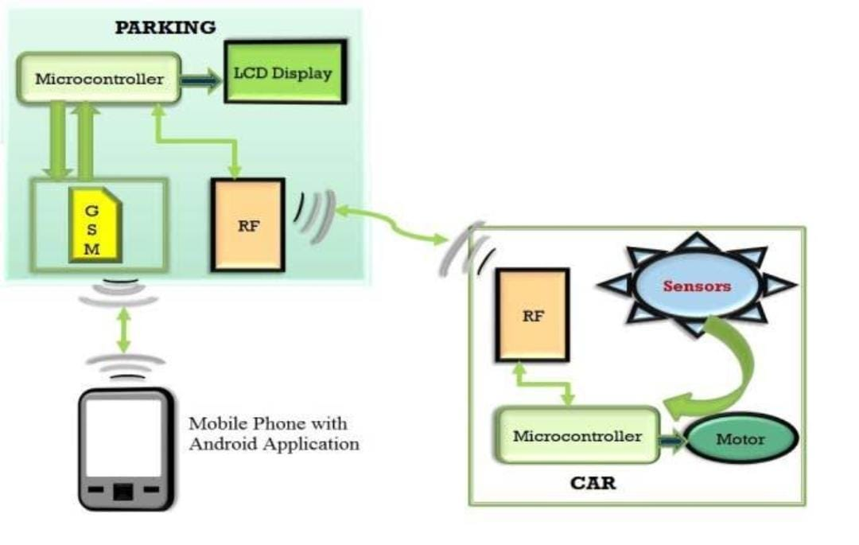

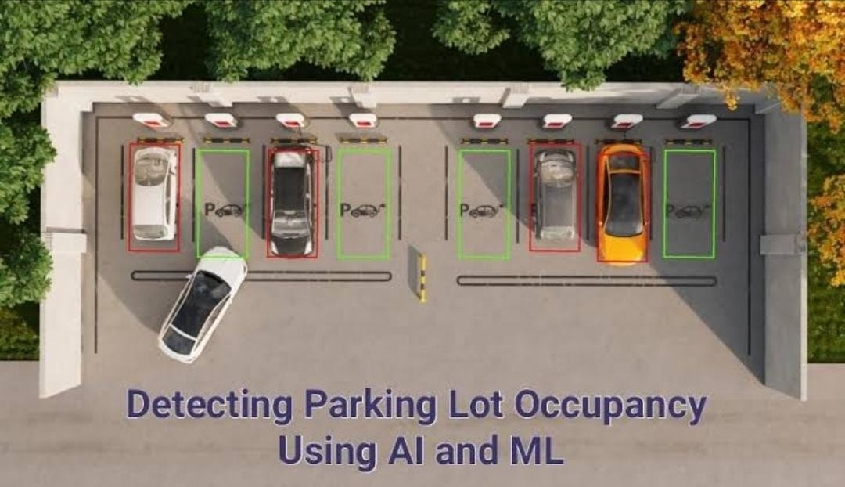

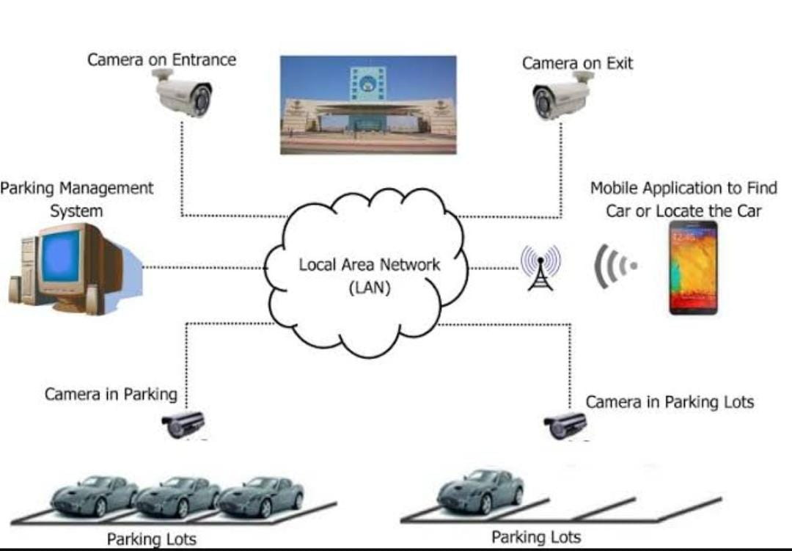

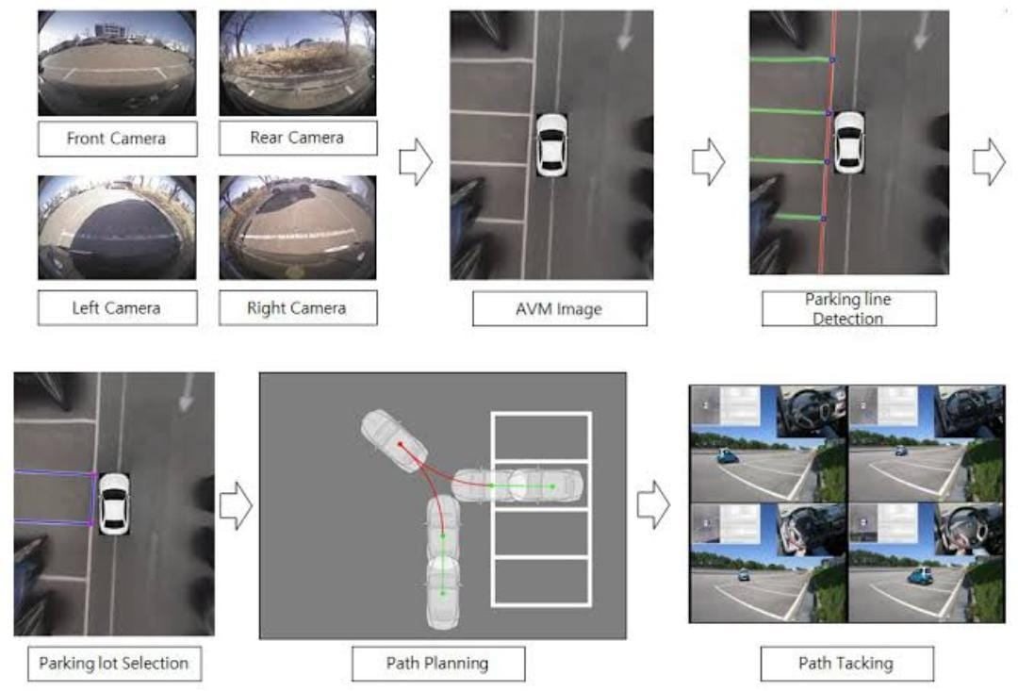

# [CHAPTE](https://1.bp.blogspot.com/-dODuK8N5h1Q/Wlnyb3V9HFI/AAAAAAAACL4/WxQtCJ1pM5wccDABg4wIrTBUB0vlikXQQCLcBGAs/s1600/poly1.jpg)R 9 CONCLUSION

* 1. **CONCLUSION**

The package was designed in such a way that future modifications can be done easily. The following conclusions can be deduced from the development of the project:

* Automation of the entire system improves the efficiency
* It provides a friendly graphical user interface which proves to be better when compared to the existing system.
* It gives appropriate access to the authorized users depending on their permissions.
* It effectively overcomes the delay in communications.
* Updating of information becomes so easier
* System security, data security and reliability are the striking features.
* The System has adequate scope for modification in future if it is necessary.

# REFERENCE

[1] Prof. Denis Ashok (Ph. D), Akshat Tiwari,Vipul Jirge(2020),Smart Parking System using IoT Technology,2020 International Conference on Emerging Trends in Information Technology and Engineering(ic-ETITE)

[2] Jahnvi Nimble,Priyanka Bhegade,Snehal Surve,Priya Chaugule,(2016) Automatic Smart Car Parking System, International Journal Of Advances in Electronics and Computer Science,Vol-3,Mar-2016.

[3]ElakyaR,Juhi Seth,Pola Ashritha,R Namith(2019),Smart Parking System using IoT,International Journal of Engineering and Advanced Technology(IJEAT),Vol-9,Octorber 2019.

[4] Wael Alsafery,Badraddin Alturki,Stephan Reiff-Marganiec & Kamal Jambi.Smart Car Parking System Solution for the Internet of Things in Smart Cities

[5] Praveen, M., & Harini, V. (2019). NB-IOT based smart car parking system. 2019 International Conference on Smart Structures and Systems (ICSSS).

[6] Bonde, D. J., Shende, R. S., Kedari, A. S., Gaikwad, K. S., & Bhokre, A. U. (2014). Automated car parking system commanded by Android application. 2014 International Conference on Computer Communication and Informatics.

[7] Chowdhury, L. H., Mahmud, Z. N. . Z., Islam, I.-U., Jahan, I., & Islam, S. (2019). Smart Car Parking Management System. 2019 IEEE International Conference on Robotics, Automation, Artificial-Intelligence and Internet-of-Things (RAAICON).

[8] Jayakshei Dadaji Bachhav1; Dept. Of Electronics and Telecommunication, SNJB’s COE,Chandwad,Maharashtra, India ,Prof. Mechkul M. A.2; SDept. Of Electronics and Telecommunication, SNJB’s COE, Chandwad,Maharashtra, India,” Smart Car Parking System”, (IRJET), Volume: 04 Issue: 06 | June - 2017

[9] Soundarya Rajesh, Dr. M.G. Sumithra, “Smart Parking system using Image processing”, International Research Journal of Engineering and Technology(IRJET), Vol 05, Issue 04, Apr42018. [10] Balwant K. Patil, Avinash Deshpande, Sonal Suryavanshi ,Rudresh Magdum, Manjunath, “Smart Parking System for Cars”, International Conference on Recent Innovations in Electrical, Electronics & Communication Engineering (ICRIEECE).

[11] Jiang Ruili, Wang Haocong, Wang Han University of Electronic Science and Technology of China, Chengdu, China; Dr Eoin O’Connell Computer Science and Information Systems Department University Of Limerick; Dr Sean McGrath Electronic & Computer Engineering Department University Of Limerick, “Smart Parking System Using Image Processing and Artificial Intelligence”, International Conference on Sensing Technology (ICST)-2018

[12] Abhirup Khanna; Rishi Anand , University of Petroleum and Energy Studies (UPES) Dehradun, Uttarakhand, “IoT based Smart Parking System”; 2016 International Conference on Internet of Things and Applications (IOTA) Maharashtra Institute of Technology, Pune, India 22 Jan - 24 Jan, 2016

[13] Bibi, N., Majid, M. N., Dawood, H., & Guo, P. (2017). Automatic Parking Space Detection System. 2017 2nd International Conference on Multimedia and Image Processing (ICMIP).

[14] Jaspreet Kaur,(2019).Implementation of Smart Parking using Artificial Intelligence; Computer Science and Engineering, Patiala Institute of Engineering and Technology for women, Nandpur kesho. August 2019 IJSDR, Volume 4.

[15] Vinay Raj Tripathti, Dept. of Electrical & Electronics, KIET Group of Institutions,Ghaziabad;2020 International Conference on Electrical and Electronics Engineering (ICE3-2020).